Puertas Lógicas

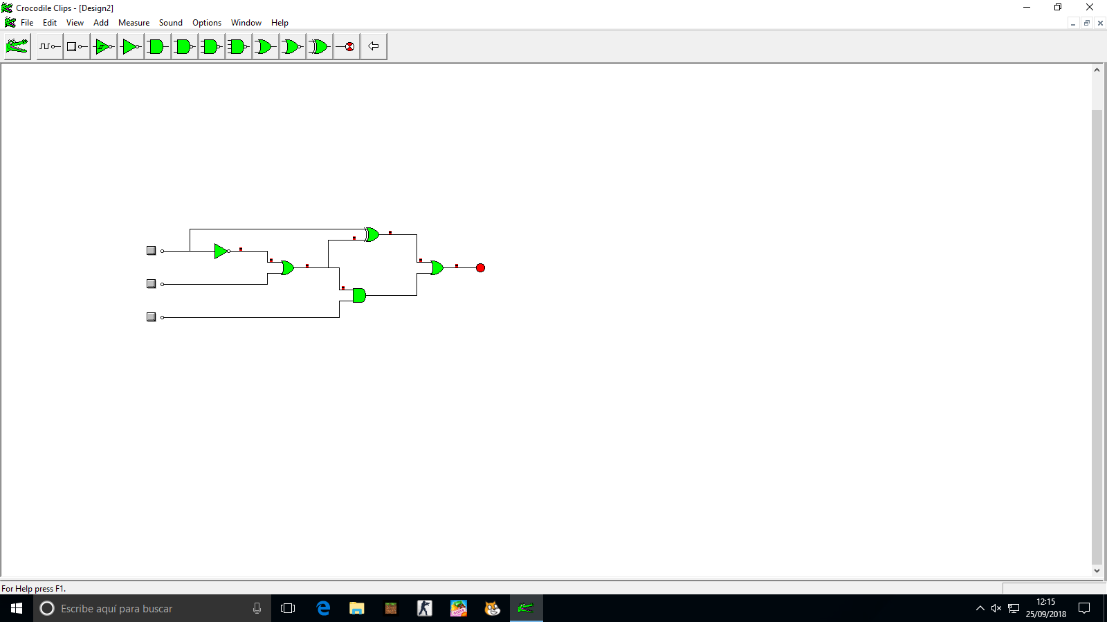

**Ecuación:** *a’·(a’+b)+a·(a’+b)’+(a’+b)·c*

|  |  |  |  |
| --- | --- | --- | --- |
| A | B | C | Salida |
| 0 | 0 | 0 | 1 |
| 0 | 0 | 1 | 1 |
| 0 | 1 | 0 | 1 |
| 0 | 1 | 1 | 1 |
| 1 | 0 | 0 | 1 |
| 1 | 0 | 1 | 1 |
| 1 | 1 | 0 | 0 |
| 1 | 1 | 1 | 1 |

Tabla de Valores